The Bradford on Avon & Melksham Health Partnership Number of Responses: 550

Patient Questionnaire Results February 2013

Section 1 - Methods of communication

Which method of communication do you most often use to get in touch with the surgery?
By telephone 75% = Improvement on last
By visiting the surgery 16% years results
By post 1%
Other (please state below) 4% = More work still to be
No response 4% done
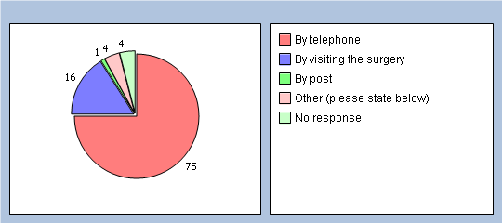
Last year 77.6% chose ‘telephone’ and 0.9% chose ‘other’ ie: on-line service

If you chose 'other' please state here

Are you aware the practice provides the following methods of communication?
Telephoning/texting the 24 hour appointment cancellation line (01225 860025)
Yes 73%
No 25%
No response 2%
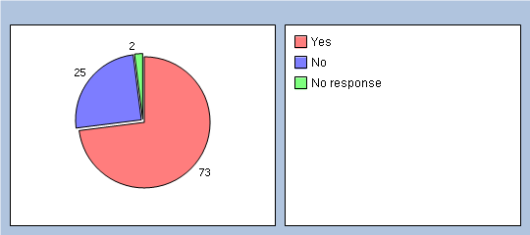
Last year 39% said yes

Practice website (www.boamhp.co.uk)
Yes 63%
No 32%
No response 5%
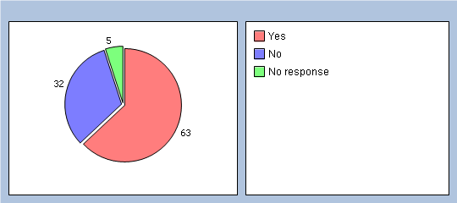
Last year 32% said yes

Book & cancel appointments on-line via the practice website
Yes 46%
No 50%
No response 4%
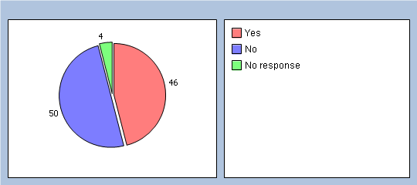
Last year 20.8% said yes

Text message reminders to your mobile phone the day before your appointment
Yes 58%
No 36%
No response 6%
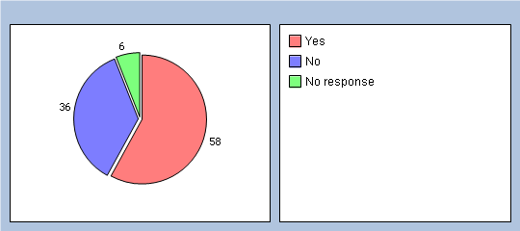
Last year 27.1% said yes

Ordering repeat medication on-line via the practice website
Yes 39%
No 56%
No response 5%
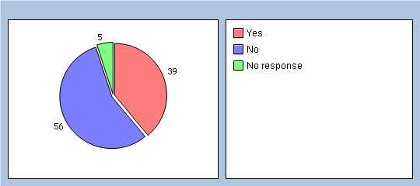
Last year 29.3% said yes

Updating your contact details on-line via the practice website
Yes 33%
No 61%
No response 6%
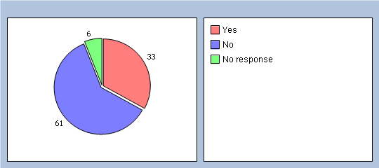
Last year 22.7% said yes

The 'Patient Voice' e-mail group boamhp.patientvoice@nhs.net - for patients who would like to provide the practice with opinions/feedback about services at the practice
Yes 27%
No 66%
No response 7%
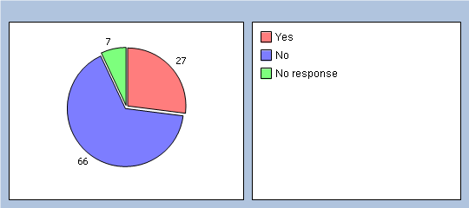
Last year 24.3% said yes

The quarterly Patient Participation Group Meetings - for patients to get involved and learn more about the practice
Yes 36%
No 58%
No response 6%
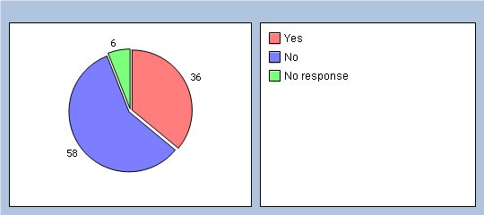
Last year 42.6% said yes

Practice Newsletter in patient waiting rooms & via the practice website
Yes 49%
No 46%
No response 5%
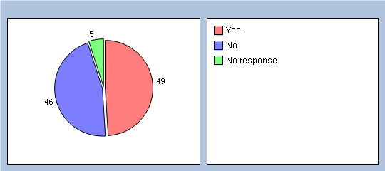
New question, can’t compare to last year.

Feedback form, via the home screen of the practice website
Yes 27%
No 66%
No response 7%
New question, can’t compare to last year.

Section 2 - Ease of communication

How easy is it for you to contact the practice by telephone?
Very easy 33%
Fairly easy 29%
Sometimes difficult 26%
Very difficult 8%
Don't know 1%
No response 3%
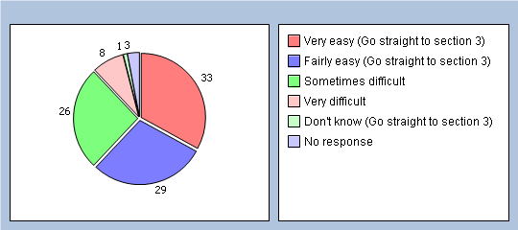
Last year very easy & fairly easy came to 76.3%
This year results came to 62%

If you have selected 'Sometimes difficult' or 'Very difficult' - what time of day do you find is most difficult?
8:30am-10:30am 29%
11am-1pm 2%
1pm-2pm (lunchtime) 0%
2pm-6pm 0%
Don't know 2%
No response 67%
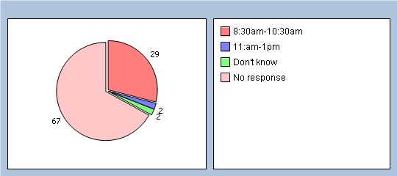
Last year 8.30-10.30am was also chosen as most difficult

Last year
20.7 % chose the appointment desk
2.1% chose Results Service
And if you are a patient of The Health Centre, BOA, which department do you find less easy to contact?
Patient Liaison/Home Visits 1%
Appointments Desk 31%
Results Service 0%
General Enquiries 1%
Don't know 5%
No response 62%

Section 3 - Convenience

In addition to appointments (and telephone consultations) offered during the day, the practice also offers some appointments (and telephone consultations) with the Doctors outside normal working hours (before 8am and after 6:30pm).
This is classed as Extended Hours - were you aware of this service?
Yes 45%
No 51%
No response 4%
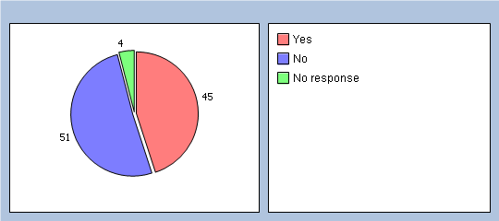
Last year 40% said Yes

If YES, how do you rate this service?
Very good 16%
Good 14%
Fair 1%
Poor 0%
Very Poor 0%
Don't know 12%
No response 57%
If NO, would you benefit from this service?

Yes 38%
Last year the results showed very similar results for this question.

No 16%
No response 46%

Is convenience of appointment times important to you?
Yes, I work full time so it is difficult to leave work to attend appointments 28%
Yes, I am a carer so need to arrange appointments around the person I care for 4%
Yes, I need to organise things around child care or around school hours 10%
No, convenience is not important to me 7%
No, I can attend the surgery anytime 30%
Other (please state) 6%
No response 15%

Section 4 - Appointment availability

How long did you wait to obtain your most recent appointment with a Doctor at the practice?
One day 25%
2 days 10%
3 - 4 days 15%
5 days 8%
6 - 7 days 15%
8 days or longer 19%
No response 8%
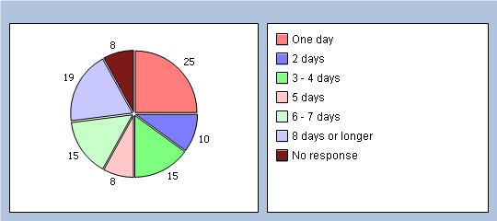
New question, can’t compare to last year.

How do you rate this?
Excellent 19%
Very good 16%
Good 18%
Fair 21%
Poor 12%
Very poor 5%
No response 9%
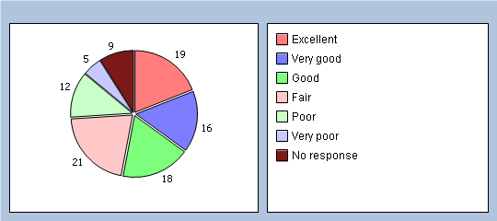
New question, can’t compare to last year.

Is there a particular GP you usually prefer to see or speak to?
Yes 69%
No 26%
No response 5%
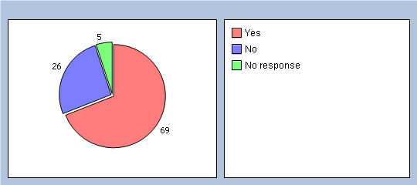
New question, can’t compare to last year.

How often do you see or speak to the GP your prefer?
Always 17%
A lot of the time 28%
Some of the time 27%
Never 3%
I don't mind who I see 15%
No response 10%
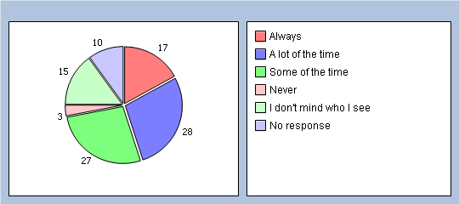
New question, can’t compare to last year.

Section 5 - Your details

It will help us understand your answers if you could tell us a little about yourself.
Which surgery do you usually attend?
The Bradford on Avon Health Centre 69%
Winsley Health Centre 10%
St Damian's Surgery, Melksham 15%
St Margaret's Surgery, Bradford on Avon 0%
No response 6%
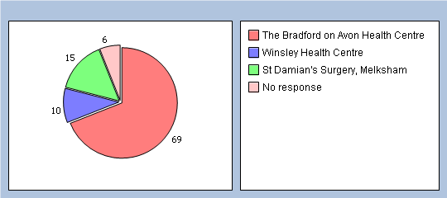
Last year the results showed very similar results for this question.

Are you?
Male 31%
Female 64%
No response 5%
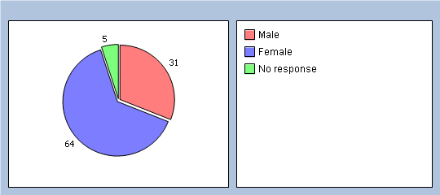
Last year the results showed very similar results for this question.

Last year the results showed very similar results for this question.

How old are you?
Under 16 0%
16 to 44 24%
45 to 64 34%
65 to 74 21%
75 and over 16%
No response 5%

Do you have a long-standing health condition?
Yes 54%
No 36%
Don't know 3%
No response 7%
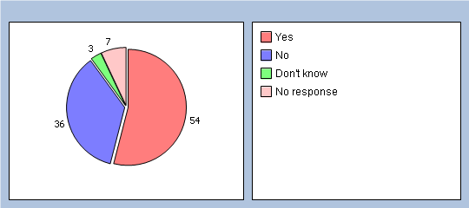
Last year the results showed very similar results for this question.

Which of the following best describes you?
Last year the results showed 32.5 Employed & 43.2 Retired from paid work.

Employed (full or part time including self employed) 41%
Unemployed/looking for work 1%
At school or in full time education 2%
Unable to work due to long term sickness 4%
Looking after your home/family 5%
Retired from paid work 35%
A full time carer 3%
Other (please state) 2%
No response 7%
What is your ethnic group?
White 90%
Black or Black British 0%
Asian or Asian British 0%
Mixed 0%
Chinese 0%
Other ethnic group (please state below) 0%
Would prefer not to say 0%
No response 10%

Section 6 - Any other comments

Of the 550 patient surveys completed, there were 270 written comments at the end of the questionnaire. Of these comments, 150 were positive and 120 were providing the practice with constructive comments.
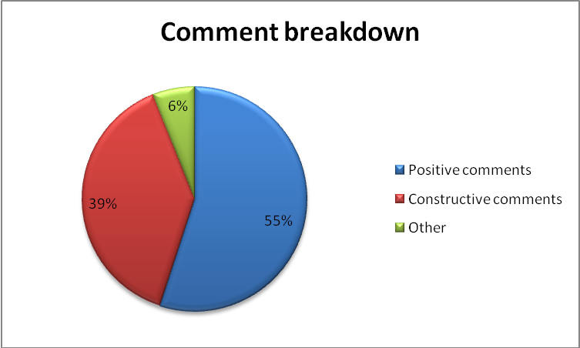
The 150 positive comments can be split into two sections:
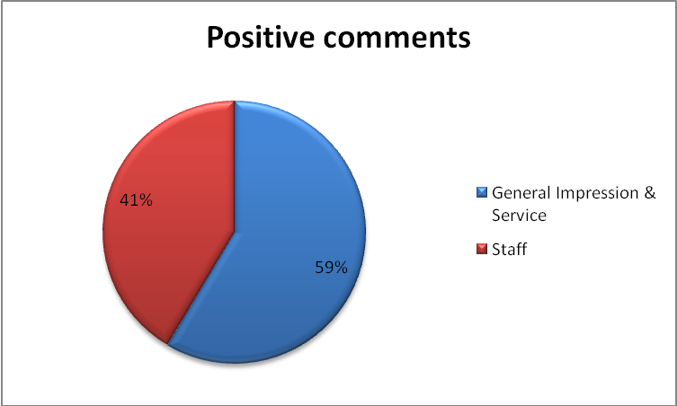
Of the 150 positive comments here are some examples:
“A great service, with a friendly atmosphere.”
“I have always felt very well cared for at the health centre and am very grateful for the excellent health, support, care and advice you provide.”
“All the Doctors and staff I have seen have been very helpful and treatment received worked well.”
“Competent, professional & reassuring. I highly recommend our surgery. Very attentive & caring, which matters alot when you are ill.”
The 120 constructive comments can be broken down into various categories:
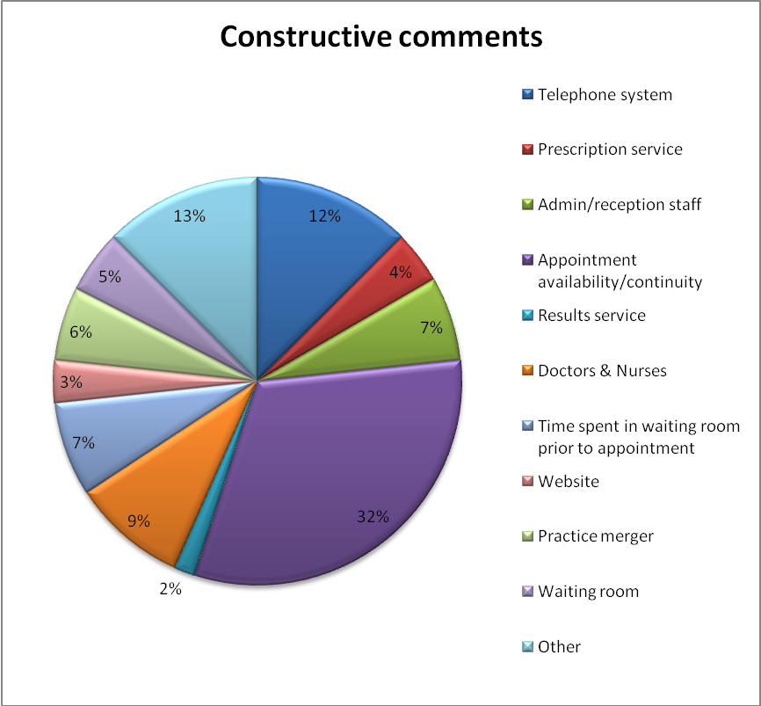
In summary, the majority of the comments were based around the availability of appointments and the lack of continuity (32%). 12% of patients mentioned the telephone line and the smallest number of comments, with 2%, was regarding the results service.
Of the 120 comments, here are some examples:
Telephone Line – “If I need an emergency appointment for one of my children, I cannot get through to Appointments first thing AM. Children always seem to be poorly through the night and it is frustrating trying to make an appointment first thing”
Prescription Service – “Difficulty in picking up a prescription that has been ordered online from the pharmacy at the health Centre, as the prescription has been mislaid on more than one occasion.”
Admin/Reception Staff – “I don't like the receptionist asking what my problem is when ringing up to book on appointment to see my Doctor (this is personal).”
Appointment Availability/Continuity – Although I have no preference as to who I see, it would be nice to see the same doctor for my family and my appointments, for the majority of the time!
Results Service – I've been waiting for wks to hear about x ray results.and now have given up. Very disgruntled.
Doctors/Nurses – “I was surprised to learn that all Dr Johnson's patients had been transferred to a male doctor without any consultation. I don’t want to be on a male Dr's list. Please put me with a female GP.” (Patient name has been removed to protect identity.)
Time spent in waiting room, prior to appointment – “Waiting time for appointments-never seen on time have waited 35mins in the past”
Practice Website – “I get angry that everyone including your Practice thinks everyone has a computer for all communications. I, for one and many like me do not.”
Practice Merger – “I am concerned the partnership and practice is becoming too big and will lose the 'personal touch and service' which has featured very strongly in the past”
Waiting Room – “Booking-in monitor at BOA does not specify which room the doctor you are to see is located in. This has proved embarrassing when waiting in the wrong area”
Other – “Why are we no longer having a chiropody service?” “Quite a few years ago the surgery seemed set up to take account of carers and their vital roles, now it seems that this has been abandoned although Carers' Support Wiltshire tell me that they are working hard with Surgeries to improve matters.”

Section 7 – Proposed Actions based on Survey results

 | Proposed action | Details | Implementation
1 | Continue publicity around alternative methods of communication | Although the survey results this year show an improvement on last year, more awareness is required | On-going
2 | Improve ability for patients to contact the appointment desk, at The Bradford on Avon Health Centre, between 8.30-10.30am | Although extra staff have been made available to answer the appointments line in the morning, the survey results show this hasn’t been enough. Propose staffing is reorganised to provide further additional support early morning. | 1st April 2013
3 | Develop a Self Help booklet for minor illness, which may reduce telephone calls to the appointment line for general advice. | The booklet would help patients know what to do, in the first instance, when they have a minor illness (flu, diarrhoea & vomiting, sore throat, etc). | 31st May 2013
4 | Continue to publicise to patients the ability to book some appointments on-line, which will reduce telephone calls to the appointment line. | More and more patients are registering to use the on-line service, publicity needs to continue. | On-going
5 | Provide patients with more information of when the phone lines are most busy, so that if they wish, they can avoid phoning the practice for booking routine future appointments at busy times. Also provide patients with interesting data about the current demand on the service. | For example: The busiest time in the day is 8.30-10.30am. The busiest times in the week are Mondays and Friday afternoons. The quietest day in the week are Wednesdays. Each member of the Appointments Team takes approximately 80-120 calls per morning. | 30th April 2013

6 | Provide more information for patients on what other services are able to help. There are many other services available which patients may not be aware of. | One example would be the Health Visitors, who are able to assist Parents with children under 5 who are not sleeping or who have behavioural problems. Another example is the new 111 national service, which has replaced NHS direct, for basic advice around minor illness. | 31st May 2013
7 | Continue to publicise Extended Hours appointment availability | Although the results this year show an improvement on last year, more awareness is required. 42% of patients rate convenience as being important.
8 | Continue to make improvements to patient continuity with their Doctor by:  a) Provide further training for appointment staff, from the Doctors, to help them guide patients to the most suitable appointment.  b) Contact other practices to find out if there are any better methods to reduce the length of time for patients to see their own GP on a routine appointment. We call this ‘the appointment backlog’. | Survey results show 69% of patients would prefer to see their ‘usual’ GP. 17% of patients felt they were able to ‘always’ see their usual GP with 55% saying they were able to see their usual GP ‘a lot’ or ‘some of the time’. 34% of patients waited 6-8 days for their most recent GP appointment. | On-going
9 | a) Reduce the number of ‘missing’ prescriptions by working more closely with St Margaret’s Pharmacy, to find way to streamline systems.  b) Publicise to patients the appointment staff are trained by the Doctors to ask for ‘some idea of the problem’ prior to booking the appointments. This is to ensure the patient is booked with the most appropriate person, within the best time frame. If patients do not wish to provide this information, it will be respected.  c) Ensure patients are informed they will need to telephone the results service to find out results of any test.  d) Doctors are able to change on a patient record which GP the patient usually sees. Publicity to be put in place to inform patients they can ask the Doctor, at their next appointment, to do this for them.  e) Ensure length of time in the waiting room is reduced by putting ‘catch up slots’ in each routine GP surgery.  f) Continue to provide information in the waiting room for those patients who do not use a computer. New practice leaflet has been revised; copies will be made available for patients in the waiting room.  g) Find ways to maintain & improve the ‘personal touch’ at the practice, even as it grows, by ensuring continuity of staff at reception, so that patients see familar faces and implement the improvements already mentioned around continuity of patients being able to see the same GP.  h) Alter the check-in machine at The BOA Health Centre to specify ‘door number’ to better guide patients where best to wait.  i) The Practice to write to Great Western Hospital NHS Trust to share with them feedback we have received from patients requesting to have a Chiropody service based in Bradford on Avon.  j) The practice is very keen to improve services with Carers and works closely with Carers support Wiltshire on this. The practice is currently working towards achieving its ‘Gold Award’ for Carers. More information of what is provided for Carers needs to be made available and we need to ensure all identified Carers have been offered a ‘Carers Check’. | Comments at the bottom of the survey gave feedback on other areas of the service. These actions are in response to these comments. | 30th April 2013  8th April 2013  30th April 2013  8th April 2013  30th April 2013  On-going  31st May 2013  8th April 2013  30th April 2013  31st May 2013

Michelle Coleman, General Manager, March 2013

