Bradford on Avon Flower Club Newsletter November 2015

Our last demonstrator was Mildred Stafford from County Durham with 'Dare to be Different’ She was really entertaining and quite a few people asked if we could have her again, so we will try to arrange that at some point. We also had four new members joining on the evening so a big welcome to them.

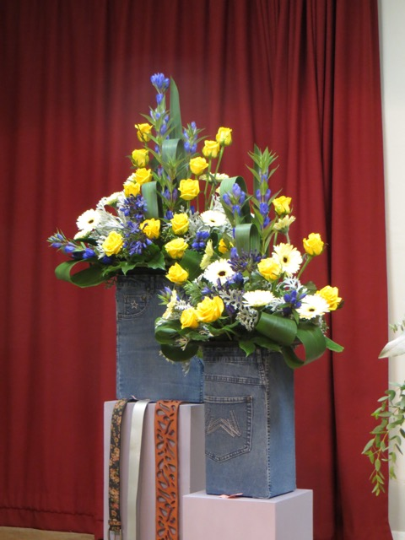

At this meeting some local lads tried to get into the hall during our meeting but Liz managed to see them off by putting an umbrella through the door handles. Never say flower arrangers are not inventive! We have been asked by the Holt Village Hall committee to lock the doors when everyone has arrived. There will be someone at the back of the hall with the key in case of emergencies and to let in latecomers. However, if you know that you are going to be late please let me know by texting to 07855 909991 although someone will keep an eye open for latecomers.

Rather belated news of the Taunton Flower show- Jan Jones got a first in the class “Catwalk” and was also awarded a trophy. Congratulations Jan.

Open Christmas Demonstration Wednesday 4th November 7.30pm at St Laurence School, Bradford on Avon. Lee Berill with Winter Wonderland
Please note that this is not the third Thursday of the month as Lee could not make Thursday 5th November (our normal meeting date).
For any one who still does not have their ticket to our main demonstration of the year (they are now selling fast!) please ring Cynthia on 01225 863640. The members were busy making Christmas table arrangements at the last practice class, to sell on the Sales table so lots of opportunity to buy something different and fun for the Christmas season.
Practice Class Wednesday 25th November 2pm at URC Hall in Holt
The theme for this class is a (Floral) Christmas cake. For this you will need a posy pad- Rosemary can supply you with one for £1.50p but please let her know before next Tuesday as she is going to the wholesalers to buy them. For more information please phone Rosemary on 01225 858751.
Thursday 3rd December Chelsea talk 7.30pm at Holt Village Hall
Cath Humphries and Lucy Ellis( members of the gold medal winning team for the South West Area of NAFAS ) will give a talk with photos all about their Chelsea experience.
We will be asking everyone to bring a plate of food/ nibbles for everyone to share afterwards.
Christmas Workshop in Masonic Hall in Bradford on Avon Saturday 5th December 10am-13.00
This is open to anyone who is interested. The price of the session is £25 and includes everything you will need to make either a Christmas wreath or a Christmas table arrangement- tuition by Margaret Murray and Lucy Ellis plus tea/coffee and home made cakes.
For more information and to book a place please phone 01225 863640. When you book please indicate if you would like to make either the Christmas Wreath or the table arrangement. Bookings need to be made by Monday 30th November to allow time for purchasing all the things needed.

Here are the designs Margaret has chosen:
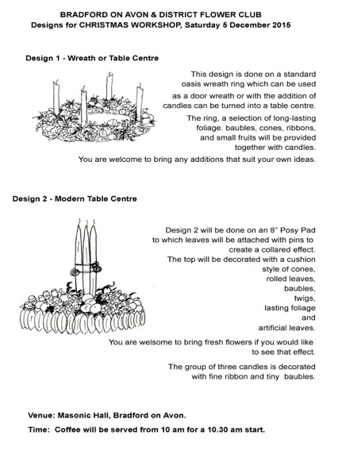

Members Dinner Thursday 7th January at Cumberwell Park.
We have the menu and Joan will be handing out menu choices to members at the Christmas Open meeting on the 4th Nov with instructions on how to pay.

Advance Warning- Jonathan Moseley Workshop Thursday 13th October 2016
The committee have decided to try something different next year and we have booked Jonathan Moseley for a day’s workshop next year. Having just been to such a workshop at the North Wilts Villages Flower Club I can highly recommend it- in fact at least half a dozen people who went to it have asked me to put their names down for next October! You may know Jonathan Mosley from his appearances on The Great Allotment Challenge on BBC2 over the last few years. He is great fun and very entertaining.
The day will start with coffee and biscuits then Jonathan demonstrates the two designs to be made. A list is sent out previously to tell everyone what to bring and having seen what to do everyone sets to! Work carries on through the afternoon after lunch before a final review of how everyone got on.
There is still a lot to be planned so more information at a later date.
Presentation of cheque to Wiltshire Air Ambulance
On 14th of October a few of the committee went along to the Air Ambulance Centre in Devizes with a presentation cheque for £200 that the club was donating. This was raised at the cream tea afternoon held earlier this year at the home of Jilly Heath who chose the Air Ambulance as her charity. This photo was in the Wiltshire Times today.

It costs £2.5 million pounds a year to run the Air Ambulance- they no longer get funding from the police. So they are delighted with any funds raised for them. Our thanks to all who came along to the cream tea and who helped raise such a great sum for this vital service.

Flower Arranger Magazine
Pam Ditte is collecting orders for the Flower Arranger magazine and the South West Area News.
The Flower Arranger costs £11.80p for 4 issues which is a reduced rate for members of NAFAS. This is really good value for a magazine which is packed full of ideas and information.
Cheques should be made out to ‘Bradford on Avon and district Flower Club’ and sent to Pam at 23 Piplar Ground, Bradford on Avon, Wilts. BA15 1XF or give her your cheque(s) at the Open meeting.
The SWAN magazine costs £4.50 for 3 issues and a separate cheque is needed to order this magazine.
For any queries please contact Pam on 01225 865700.

A few things happening in the Area:-

Wed 18th November 7.30pm Devizes Floral Art Club Open Meeting Bob Harris with “What Christmas Does to Me” Tickets £10 from 01380 725301 or 01380 828046.

Wednesday 18th November 7.30pm North Wilts Villages Flower Club. A demonstration by Nick Grounds “Bah Humbug” at the Sundial Theatre in Cirencester. Tickets are £12- telephone 01666 824813.

Tuesday 24th November 2.15pm Saltford Floral Club. Jonathan Moseley with “Flowers for the Festive Season” £12 from 0117 977 1813 or 01275 462860.

Monday 7th Dec 7.30pm Marshfield Flower Arrangement Club Open meeting Pam Lewis with “Christmas Naturally” £10 For tickets phone 01249 782668

Tuesday 8th December 7.30pm Wroughton Floral Art Andrew Lloyd “Christmas with Andrew” £12 Phone 01672 841538
The club has been offered a complimentary ticket to the following demonstrations:-
18th November Devizes
7th December Marshfield
8th December Wroughton

If any member would like to use one of these please contact me on 01225 868535. You can always go with a friend- buy another ticket and split the cost.

I have been just been asked to circulate this letter from the National Chairman of NAFAS outlining all the benefits of being a member of NAFAS. Note the date on the letter is February so the note on affiliation fees is wrong- it is now £5.40p plus £2.50 for the SW Area so the club has to pay £7.90p for each member this year.
----------------------------------------------------------------------------------
BENEFITS OF MEMBERSHIP
Club membership rates vary, depending upon the subscription levied by each individual Club. From the NAFAS Affiliation Fee of £5 per capita, VAT has to be deducted, leaving £4.25 to the charity.
Training/Testing:

[if !supportLists]• [endif]NAFAS runs Training and Testing programmes for National Demonstrators, Judges and Speakers
[if !supportLists]• [endif]A Training and Testing programme for Adjudicators and Instructors for Demonstrators, Judges and Speakers
[if !supportLists]• [endif]A Teacher Training Course is available for Tutors
[if !supportLists]• [endif]Certificated Flower Arranging Courses are held in many parts of the UK
Qualified Instructors and Adjudicators go on to coach Trainee Demonstrators, Judges and Speakers both at National and Area level.
Residential Courses and Refresher Days are held regularly for all disciplines, which Area qualified members are encouraged to attend.
The NAFAS Educational Charitable Fund has been established to benefit new and existing Clubs, through Courses, training and other such related subjects.
NAFAS Enterprises Ltd is the trading arm of the Association and administers Trading and The Flower Arranger.
The numerous handbooks written by NAFAS members are not available other than through the Association.
A privileged subscription rate to The Flower Arranger.
INSIGHT, an educational magazine produced by NAFAS 3 times a year.
Access to the NAFAS Library. Members are welcome to visit Headquarters (by prior arrangement) to do research in the Association’s extensive Library, most of the books have been donated by members over the years.
National Show, a bi-annual event often held in a different part of the country, although also open to the public, members have the opportunity of competing at the Show.
A members only Residential Event. This will become bi-annual, in alternate years to the National Show and offers members the opportunity to join with like-minded people to enjoy all things floral for a few days.
A National Photography Competition is usually held annually for members.
Westminster Abbey. The Association is fortunate to be invited throughout the year to arrange flowers in the Abbey. Last year over 100 members from all corners of the UK arranged the flowers for the many Services the Abbey holds. Areas are encouraged to put members’ names forward.
RHS. The RHS hold Shows throughout the year at their halls in London. Areas are invited to put members’ names forward to participate and each Area has, over the years, staged the NAFAS Exhibit at Chelsea.
WAFA - The World Association of Flower Arrangers – hosted by a WAFA Member Country held every three years
NAFAS members have automatic membership of WAFA member. This allows members to put their name forward to attend the Seminar and also allows them to enter the World Show as a competitor.
Besides the National and International events that take place, each Area hold amazing festivals and shows, all of which members could be involved with.
NAFAS Guidelines. NAFAS produce a range of guidelines from ‘Forming a New Look Flower Club’ to how to put together a Risk Assessment. These are available to download from the NAFAS website, or from Headquarters.
OASIS® Home & Hobby. Through the NAFAS partnership with OASIS® Home & Hobby members are eligible for a discount on purchases through their online shop.
The wheels of the Association is kept turning from its Headquarters in London by five members of staff. All National Committee meetings are held at Headquarters, which saves on costs and accommodation is available for Committee members, which is another huge saving on accommodation costs.
A full break down of the income and expenditure of the Association is given in the Annual Report, which is available from headquarters.
As most of us have been members for a good number of years we perhaps tend to forget what the benefits are – I have attempted to give a resumé of these benefits, they are all of the above and much more.
Belonging to a Flower Club and NAFAS has helped us all to build a circle of friends with a common bond. To remember how the love of flowers and the art of arranging them have enhanced so many places and touched so many people’s hearts and how many opportunities it has given us all, from placing a simple posy in a hospice, to inspiration by the many demonstrations we all enjoy, to arranging flowers in a church, cathedral or stately home.
Sue Brinton
National Chairman
February 2015

Facebook

Did you know that you can find the club on Facebook? Margaret puts photos, posters and news about the club on the site. Search for Bradford on Avon and District Flower Club. Please do have a look and ‘Like’ the page and add the club to your ‘Friends’ list to see what she adds.

If you could also share it with your friends it would mean more people would hear about the club and realise it might be worth coming along to see what we actually do!

Finally just to wish Lucy a huge message of Good Luck when she takes part in the NAFAS Designer of the Year competition (representing the South West Area) at the NAFAS Festive Flower and Food Show to be held in Blackpool from the 13th to the 15th of November. What a year for Lucy- part of the Gold winning team at Chelsea- passing her National demonstrator’s test and now the Designer of the Year competition. Well, we are all rooting for her!!

Congratulations if you have managed to plough your way through all that news! It’s all happening at Bradford on Avon and District Flower Club!

Helen
(on behalf of the committee)

