Bradford on Avon Flower Club Newsletter September 2015

The outing to Yeo Valley Organic Garden was on a beautiful sunny afternoon and the lovely things in the tea room were much appreciated. Well worth a visit. Someone there had a sense of humour as well.

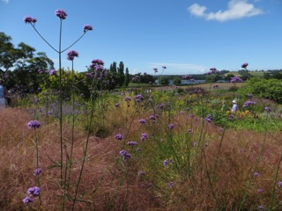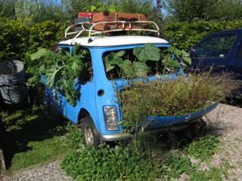

Thursday 3rd September Demonstration by David Martin “Vision of Cornwall” 7.30pm at Holt Village Hall.
We look forward to welcoming visitors for free at this demonstration so that you can find out what an enjoyable evening it is. Members please try to bring along someone who has never been to a flower club before.
Home made cakes with tea/coffee and a chance to have a chat afterwards.
The competition will be on the theme of the last practice class- Midelino Magic. Everyone can then vote by putting coins by their favourite arrangement and the winner will be the one with the highest total. All of the money will then be donated to charity.
Rosemary will bring along an example of what she would like you to have a go making at the next practice class.
I am sure some of you have started making jams and chutneys- if you can spare any please bring them along for the sales table, also any spare plants. As usual there will also be everything you need for flower arranging for sale as well.
Tickets for our Christmas Open meeting (November 4th) will be available at this meeting. We will also be taking names for the workshop in the Masonic Hall on Saturday 5th December.

“Magna Flora” Salisbury Cathedral Tuesday 15th September to Sunday 20th of September.
The team representing our club now have all the planning complete and are looking forward to the set up day on Monday 14th September.
The club thanks the team of Maureen Faraway, Jan Jones, Cynthia Booth and Liz Harris for all their work on behalf of the club.
I have already booked my ticket , which was very easy to do on line. To do so go to www.salisburycathedral.org.uk

Practice class Wednesday 23rd September 7.30pm URC Hall in Holt.
Please note this date has changed from the last Wednesday of the month to the previous week.
This will be a layered design using fruit and berries. If you are interested please phone Rosemary on 01225 858751.

Thursday 1st October Demonstration by Mildred Stafford “Dare to be Different” 7.30pm at Holt Village Hall
Mildred has not visited our club before. She comes from County Durham but combines visiting her sister in Cirencester with doing some demonstrations in the area. So a chance to see a demonstrator from a completely different area.

Open Christmas Demonstration Wednesday 4th November 7.30pm at St Laurence School, Bradford on Avon.
Please note that this is not the third Thursday of the month as Lee could not make Thursday 5th November which would have been our normal meeting date
Preparations are well under way for our main demonstration of the year.
The demonstrator is Lee Berrill from Northampton with “Winter Wonderland” As well as being a NAFAS demonstrator- Lee is a florist of many years experience.
Tickets are £12- members £10 which includes a glass of wine and refreshments. There will be a raffle to give you a chance to win one of the demonstrator’s wonderful designs also an extensive sales table.
Tickets will be available at the meeting on 3rd September.
For more information please contact 01225 863640.

Christmas Workshop in Masonic Hall in Bradford on Avon Saturday 5th
December 10am-13.00
This is open to anyone who is interested. The price of the session is £25 and includes everything you need to make either a Christmas wreath or a Christmas table arrangement- tuition by Margaret Murray and Lucy Ellis plus tea/coffee and home made cakes.
We will be starting to take names and payment at the meeting on 3rd September. For more information and to book a place please phone 01225 863640. When you book please indicate if you would like to make either the Christmas Wreath or the table arrangement.

Members Dinner on Thursday 7th January.
The committee discussed this at the last committee meeting and the dinner will be at the Cumberwell Golf Course where it was held in January this year. The feedback from members was good, parking was easy so Joan has already booked us in!

Garden visit Saturday August 6th 2016
Well we do have to think ahead! Cath has now booked the coach to Kew and to whet your appetite here are a couple of photos she took there recently. If you have never been it is a marvellous place to visit with a lot to see.
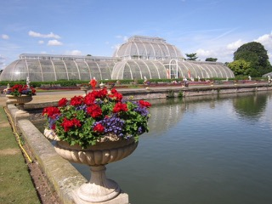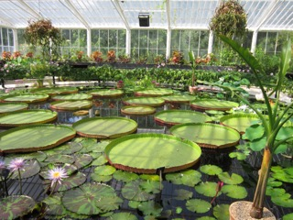

The cost of the coach and entry will be approximately £30 with members paying a bit less. More information nearer the time.

Concert at St Margaret’s Hall Bradford on Avon 10th September
Two of our members Liz Harris and Cynthia Booth are going to arrange 2 pedestal arrangements on either side of the stage at a concert in St Margaret’s Hall on Thursday 10th September, which is part of the Bradford on Avon Arts festival. The title of the concert is “An English Country Garden” and will feature Folk, Blues and Jazz by the following – Mike Scott, Rosie Upton, Pete MacGregor, This side of Paris, Andrew Bazeley and Bryony McGinty. The theme of the whole Arts Festival is “Flower Power” so this will be an opportunity to promote our club and make a contribution to the very relevant theme.
For more information and to buy tickets go to www.boaartsfestival.com

South West Area Annual General Meeting and Demonstration 2015
Saturday 28th November 2015 10am coffee- 4pm

This will be held at the White Horse Country Park, Coach Road, Westbury, Wiltshire, BA13 4LX.
10.30am AGM
1.30pm Presentation of cheques from President’s Day
1.45pm Demonstration – Elizabeth Gordon and Emily Broomhead “Tis the Season”
Tickets are £27.50 which is for the demonstration and a carvery style lunch. This is the final celebration of the South West Area’s Diamond Anniversary.
There will be information about the lunch on the board at the David Martin demonstration plus a list for names. Cheques should be made out to South West Area of NAFAS.
Alternatively send your cheque with name, Tel No and e-mail address plus a stamped addressed envelope to Glynis Lockhart, 55 Ruskin Drive, Warminster BA12 8HS
I have checked with the Area secretary and it is not possible to buy a separate ticket just for the demonstration.

Received from the Area Secretary

- Notice that the Designer’s Forum Open meeting has been rearranged for Saturday 10th October 2015. The demonstration will be held in Shipham Village Hall.
- A poster distributed at the council meeting about the Farmborough and District Open Meeting should have said Monday 2nd of November not 2nd December

Events in the Area

Innovation Design Study group have a demonstration by Neil Whittaker on Saturday 3rd October at 2pm in the Memorial Hall, Royal Wootton Bassett SN4 8EN. Tickets are £12.50 including refreshments.For further information or to buy a ticket contact Lucy Ellis 01380831469.

Calne Flower Arrangers have a demonstration by Michael Bowyer on Friday 23rd October at 7.30pm in Christ Church, Derry Hill, Calne. Tickets are £10 and includes refreshments. Tel:- 01249 814283

Corsham Flower Arranger’s Club have a demonstration by David Martin on the 9th November at 7.30pm in the Town Hall, High Street, Corsham. Tickets are £10. Enquiries:- 01249 713537

Holt Annual Flower Show Saturday 12th September 2pm
There are 6 Floral Art classes that I am sure some of you would like to enter, particularly as the club has their meetings in the Village Hall in Holt.
A decorated Frame- Natures Pallet- Inspired by Ikebana- It’s a small world- Solo Performance and Honey Bunch.
For further information and details of how to enter phone 01225 782516 or 01225 782665 or 01225 782780.

Bradford on Avon Flower and Produce Show Sunday 13th September 2pm
There are 3 Floral Art classes- a petite exhibit- Frenzy and Carnival. Parishoners of Bradford on Avon and Avoncliff are entitled to enter.
Schedules and entry forms available from the Council office or contact show secretary at nicola.jr@virgin.net or 07903 533550
Well- another long newsletter- it must mean the summer is nearly over and everything is starting up again!

Hope to see you at some of these events.

Helen

